RESEARCH STUDY - FEBRUARY 2026
AI FOR AMERICANS FIRST
AI Protectionism, Energy and Semiconductors: US/Europe Divergence Trajectories 2024-2030
Integrated Geostrategy and Economic Analysis - CHAPTER VI TER
76.9% of global operational AI compute = USA | 1.59x EU/US energy cost (PPP-adjusted) | 3.46:1 US/EU CACI ratio (Power Mode)

Fabrice Pizzi
Universite Paris-Sorbonne
Master 2 Intelligence Economique - Intelligence Warfare
Paris - February 2026 | 7 Chapters | 4 Prospective Scenarios | 3 Geographic Zones
Keywords: artificial intelligence, technological protectionism, semiconductors, export controls, sovereign compute, AI geopolitics, France, United States, China
CHAPTER VI TER
Consequences for Asia and China
Asia is the main target and the primary victim of American AI protectionism. This chapter analyzes the consequences of the containment regime on China, the pressure on the 'Tier 1' allies (Japan, South Korea, Taiwan), and the emergence of Southeast Asia as a secondary compute hub. The analysis highlights the transition from a logic of interdependence to a logic of total decoupling.
6ter.1 China: resilience under maximum containment
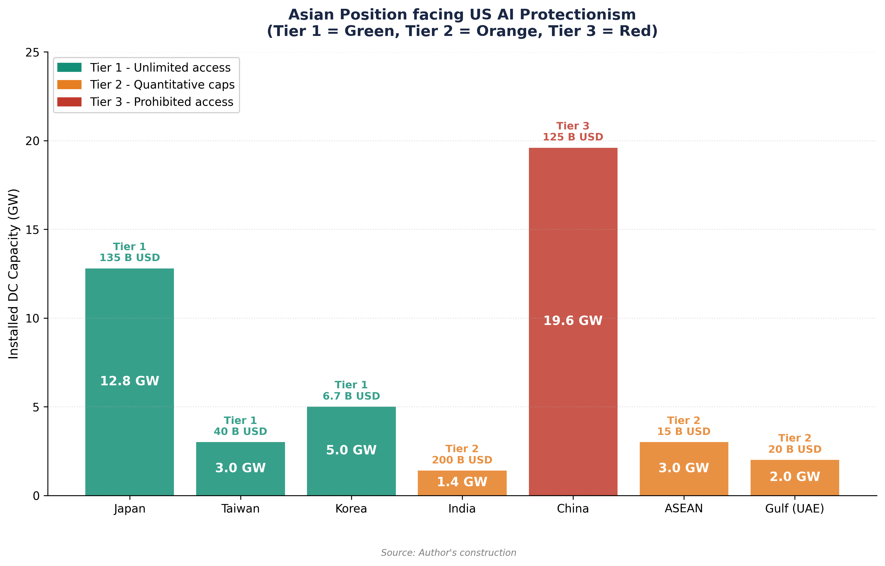

6ter.1.1 The impact of total hardware decoupling
China faces the most severe restrictions in history. Since the October 2022 and 2023 rules, supplemented by the June 2025 'Superchips' restrictions, Chinese access to advanced AI accelerators (Nvidia H100, B200) is de facto prohibited. In April 2026, the US/China CACI Power Mode ratio is 2.14:1, a significant gap that measures the effectiveness of the containment (Chapter III).
This asymmetry forces China into a strategy of hardware substitution. Huawei (Ascend 910C), Biren, and Moore Threads are developing national accelerators which, although 1 to 2 generations behind Nvidia, allow for the training of Large Language Models (LLMs). ByteDance has notably placed an order for 100,000 Ascend 910B chips in 2024 to compensate for the H100 shortage.[1] However, the yield of SMIC's 7nm and 5nm nodes remains limited by the lack of EUV lithography (ASML export prohibition), creating a structural ceiling for Chinese hardware sovereignty.
6ter.1.2 Reorientation toward 'Global South Compute'
In response to domestic containment, China is deploying an international compute strategy. The ByteDance-Pecém project in Brazil (38 billion USD, Chapter VI bis) and investments in Malaysia (Johor hub) illustrate this desire to build 'Geographic Redundancy' for Chinese compute. By installing data centers in Tier 2 countries (Malaysia, Brazil, UAE), Chinese actors seek to bypass direct export controls, even if the US 'Affiliates Rule' (November 2025) seeks to close this loophole by extending restrictions to foreign subsidiaries of listed entities.[2]
6ter.2 The Tier 1 Allies: Japan, South Korea, Taiwan
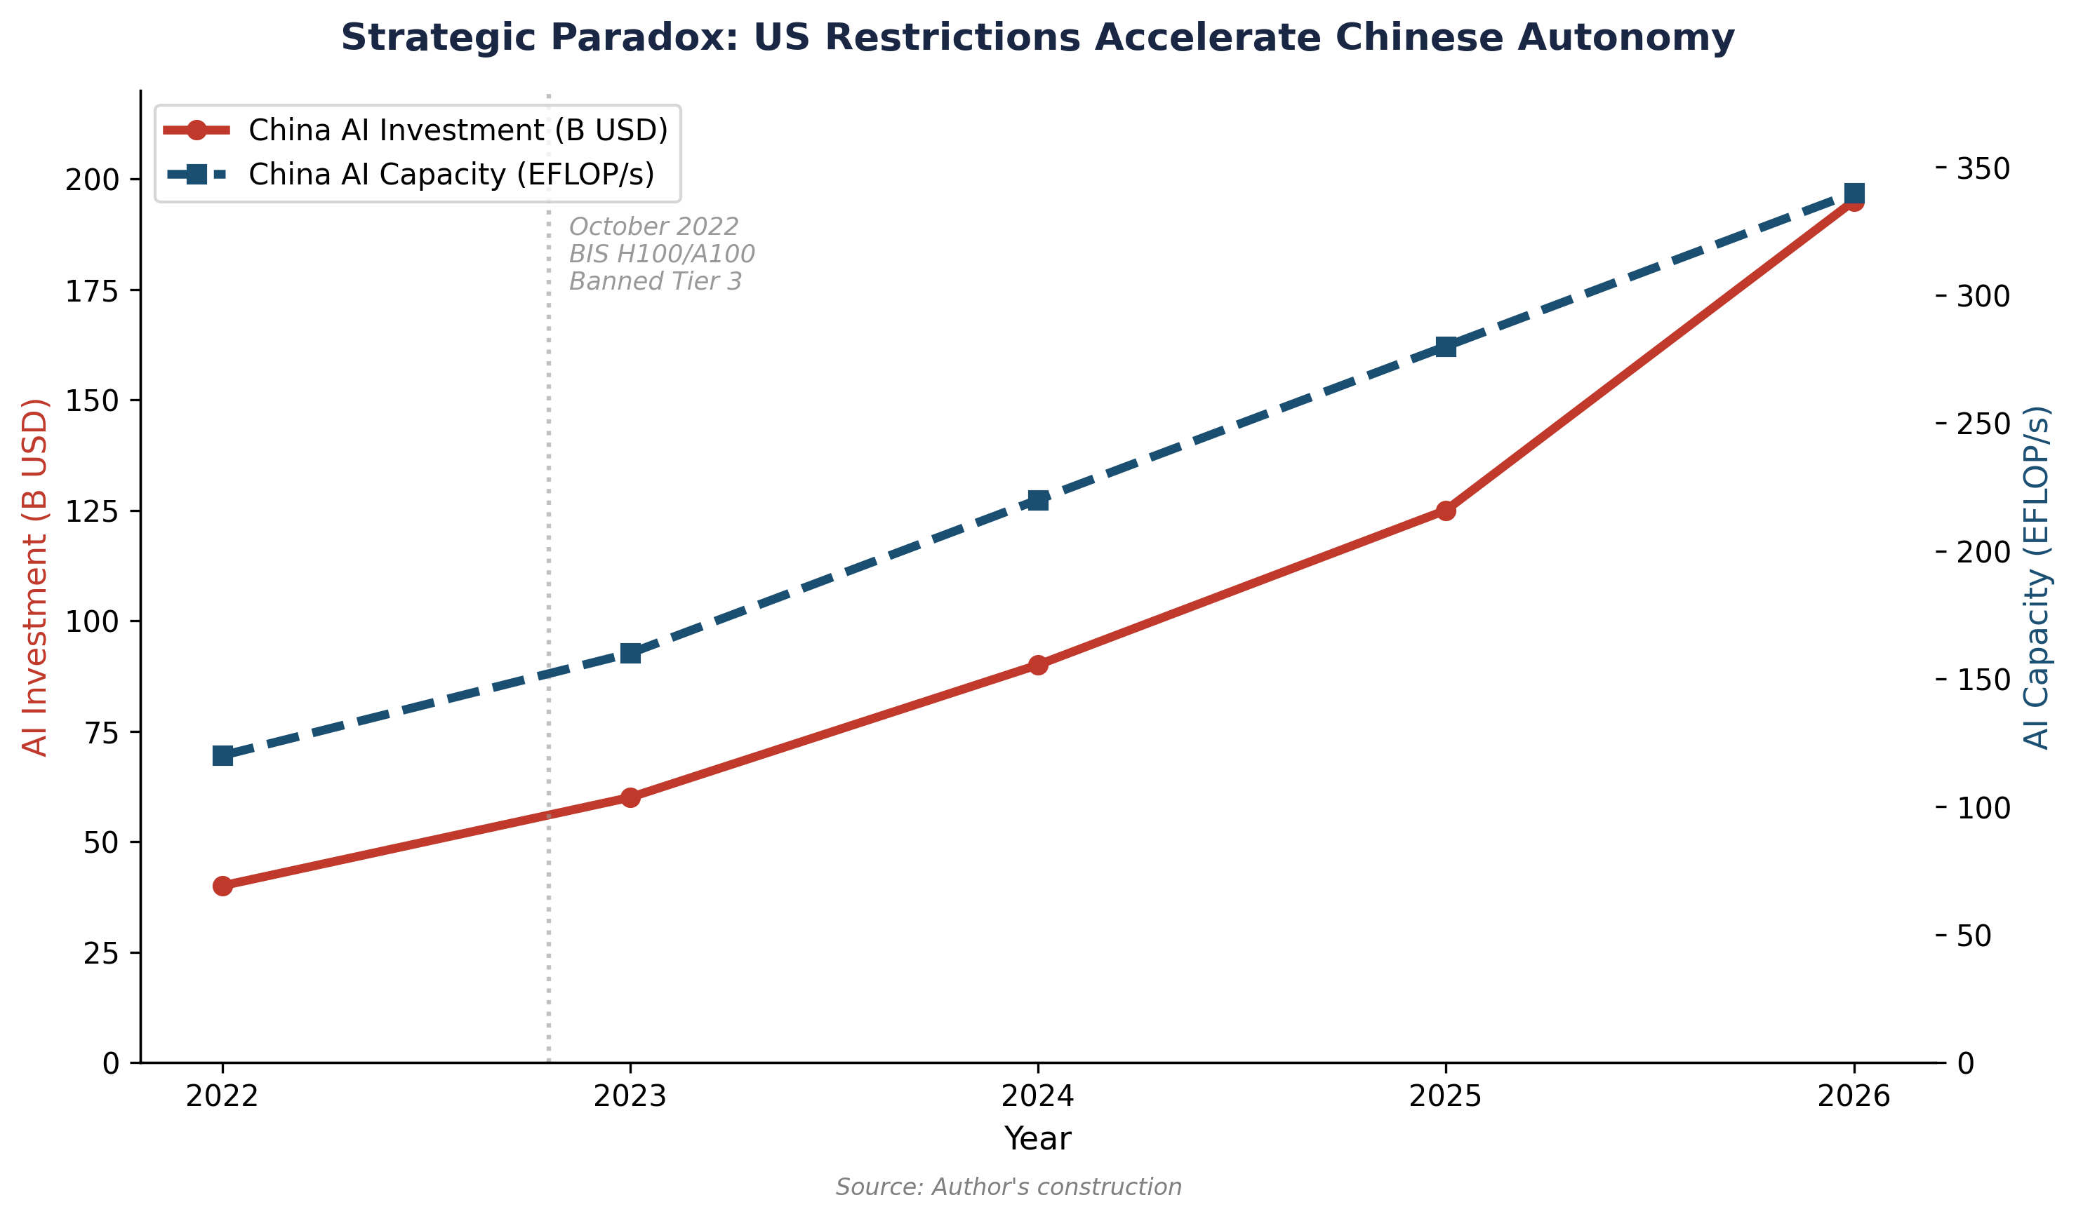

6ter.2.1 Taiwan: the geopolitical fab under pressure
Taiwan (TSMC) produces 92% of the world's most advanced semiconductors. Under US protectionism, Taiwan is under dual pressure: (i) the 'hollowing out' of its production toward the US (Arizona Fabs) to satisfy American resilience requirements, and (ii) the hardening of export controls toward China, its primary trading partner. The 'Geographic Diversity' required by the US (Chapter IV) creates a risk of industrial dilution for Taiwan, while increasing the cost of chips for its domestic ecosystem.


6ter.2.2 Japan and South Korea: the RISC-V and alternative foundry bet
Japan (Rapidus) and South Korea (Samsung) are investing massively to break the TSMC/Nvidia duopoly. Japan has launched the 'LSTC' (Leading-edge Semiconductor Technology Center) to develop 2nm chips by 2027. South Korea, through the 'AI Semiconductor Strategy', aims to capture 80% of the AI memory market (HBM3e/4) by 2030.[3] For these allies, US protectionism is a double-edged sword: it offers protected access to the US market (Tier 1) but imposes alignment on export controls that damages their relations with China.


6ter.3 Southeast Asia: the new 'Middle Ground'
Malaysia (Johor), Vietnam, and Indonesia are emerging as the new preferred destinations for data centers. Malaysia attracted more than 15 billion USD in data center investments in 2024-2025 (Microsoft, Google, ByteDance, Nvidia/YTL).[4] These countries take advantage of their Tier 2 status to host both American and Chinese infrastructure, creating a 'Compute Non-Alignment' similar to Brazil's, but with much greater proximity to the Chinese supply chain.
6ter.4 Synthesis: toward a fragmented Asian compute
Asia is fracturing into three distinct zones: a 'Sovereign Chinese Zone' (hardware substitution, massive state investment), a 'Tier 1 Pro-US Zone' (high-end foundry, total alignment), and a 'Tier 2 Emerging Zone' (arbitrage hub, US-China duality). This fragmentation increases the complexity of global supply chains and significantly raises the marginal cost of compute for the entire region.
Table 18. Comparison of AI hardware capacities in Asia (April 2026).
Source: Author's construction, calibration on the public dashboard.
Country/Region | US Status | Primary Hardware | CACI Power Mode (est.) | Strategic Constraint
China | Tier 3 | Huawei Ascend, Biren | 0.47 (relative to US) | SMIC yield (7nm ceiling)
Taiwan | Tier 1 | TSMC (Nvidia/AMD) | 0.85 (relative to US) | Resilience-driven offshoring
Japan | Tier 1 | Rapidus/Nvidia | 0.62 (relative to US) | Energy cost + 2nm execution risk
Malaysia | Tier 2 | Nvidia (H100/H200) | 0.15 (relative to US) | US import caps + energy grid

Notes
1. Reuters (2024), 'ByteDance orders 100,000 Huawei AI chips'.
2. BIS (November 10, 2025), 'Implementation of the Affiliates Rule'.
3. South Korea Ministry of Science and ICT (2025), 'AI Semiconductor Strategy 2030'.
4. MIDA (2025), 'Malaysia Data Center Investment Report'.

License and Disclaimer. This work, 'AI for Americans First', is made available under the terms of the Creative Commons Attribution-NonCommercial-ShareAlike 4.0 International (CC BY-NC-SA 4.0) license. You are free to share and adapt the material for non-commercial purposes, provided you properly attribute the work to Fabrice Pizzi (Université Paris-Sorbonne) and distribute your contributions under the same license. This document is provided for educational and research purposes only.
Public Dashboard : https://mo0ogly.github.io/America-First-IA/dashboard/
Repository : https://github.com/mo0ogly/America-First-IA
AI for Americans First - Fabrice Pizzi - Chapter VI ter

